EMERGING METHODS OF EARLY DETECTION OF FOREST FIRE

**MODEL BUILDING ADDING DENSE LAYERS**

|  |  |
| --- | --- |
| Team ID | PNT2022TMID20340 |
| Project Name | Emerging methods of early detection of forest fire |

# ADDING DENSE LAYERS:

The name suggests that layers are fully connected (dense) by the neurons in a network layer. Each neuron in a layer receives input from all the neurons present in the previous layer.

Dense is used to add the layers.

## Adding Hidden layers:

This step is to add a dense layer (hidden layer). We flatten the feature map and convert it into a vector or single dimensional array in the Flatten layer. This vector array is fed it as an input to the neural network and applies an activation function, such as sigmoid or other, and returns the output.

## Adding output layer:

This step is to add a dense layer (output layer) where you will be specifying the number of classes your dependent variable has, activation function and weight initializer as the arguments. We use add () method to add dense layers. In this layer, no need of mentioning input dimensions as we have mentions them in the above layer itself.

## IMPORT LIBRARIES:

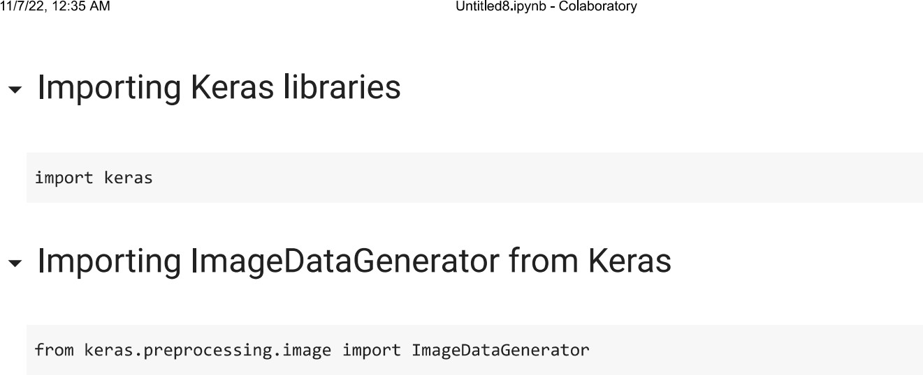

**IMPORT ImageDataGenerator FROM KERAS:**

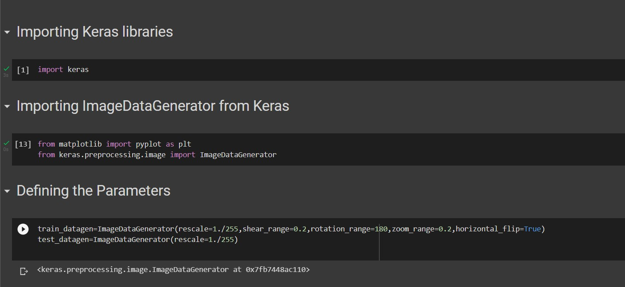

# APPLYING ImageDataGenerator to train dataset:

ply**flow_from_directory ( )**methodfor Train folder.

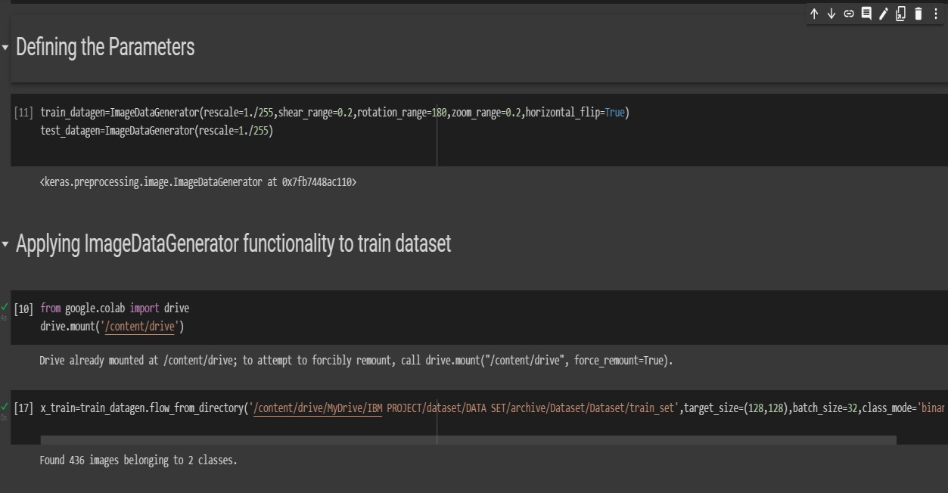

# APPLYING ImageDataGenerator to test dataset:

Applying the **flow_from_directory ( )** methodfortest folder.

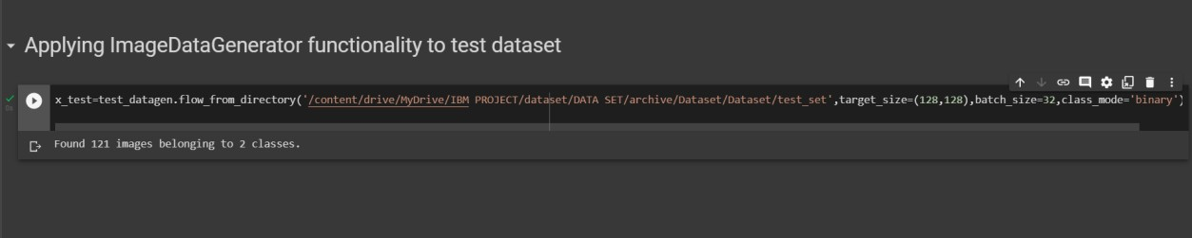

# IMPORTING MODEL BUILDING LIBRARIES:

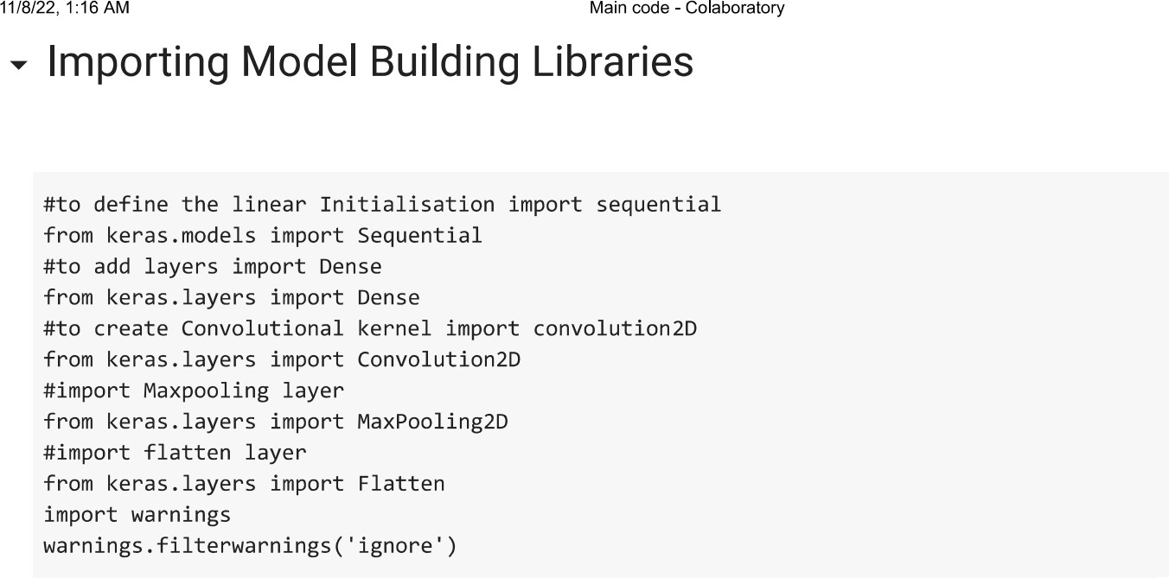

## INITIALIZING THE MODEL:

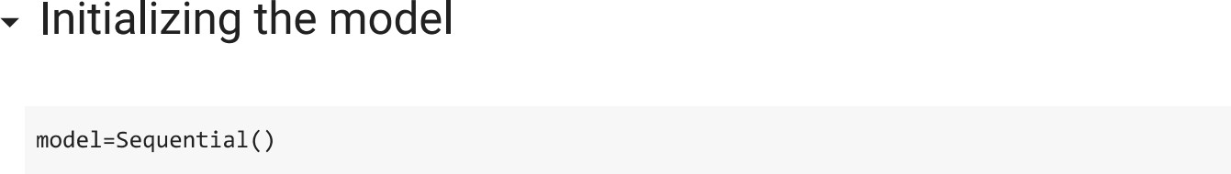

**ADDING CNN LAYERS:**

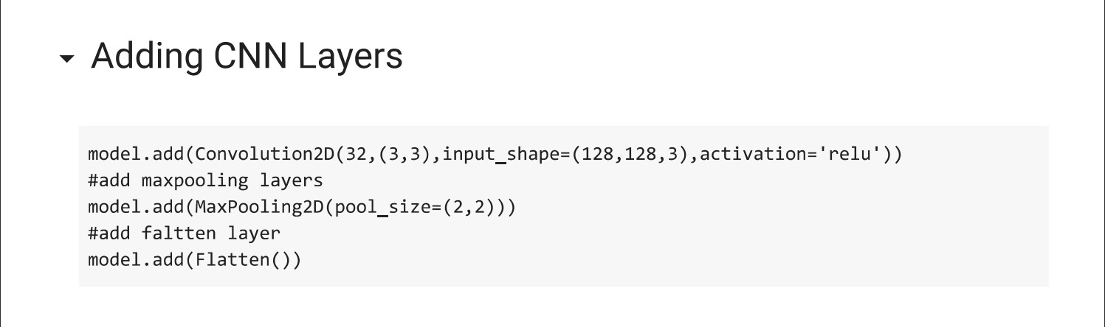

## ADDING DENSE LAYERS:

